**She Said**

**Becci Robbins (Re)Writes SC History for Everyone**

By Ed Madden

ou don't have to talk to Becci Robbins for very long before you realize there are three key ideas that drive her writing.

Y

The first is urgency. She says it is important to record stories now while the people who lived them are still alive. When her friend Merli Truesdale died in 2019, he left behind a huge collection of political materials and music. As his friends sorted through "all this magnificent stuff," she thought, "We've gotta get these stories down."

"Doing this work," she says, "has made me understand the importance of capturing people's stories while you can. I didn't do that in my own family. I didn't ask my father or mother the questions I wish I could have asked them now I didn't think to ask and now I can't."

There is•an urgency for her to the issues as well as the people. As she writes at the end of her book on civil rights activist Modjeska Monteith Simkins, the first of five she has published on South Carolina history: "The political and social dynamics of exclusion, extremism, and racism remain stubbornly intact in our home state. I share her frustration and sense of urgency."

The second key idea for Robbins is history-or a richer and more accurate sense of history, especially when it comes to shared narratives about who we are and how we got here. Things we should know about our history are kept from us, she says, intentionally or unintentionally. If we only knew those stories it might change the way we understand our past and our future.

In a series of five small booklets published over the past decade, Robbins has diligently explored and amplified historical moments and voices too easily forgotten, too long elided, too often distorted or ignored or erased. The first three tell the stories of three women who were outspoken advocates for social justice for African Americans, for lesbians and gay men, for women: Modjeska Monteith Simkins, Harriet_Hancock, and Sarah

Leverette. This trio of activist profiles was followed by two booklets that document stories of resistance. The first focused on the civil rights and labor movements, the second on radical youth movements in Columbia of the 1960s and 1970s.

Together, these booklets offer a complex history of South Carolina through, as Robbins puts it, "things you didn't learn in school." As an example, she points to an unprecedented interracial youth congress held atTownship Auditorium in 1946. The meeting of the Southern egro Youth Congress (SNYC) lasted three days, drew over 3000 attendees (about 800 delegates from Southern black colleges), and featured such internationally known speakers as W.E.B. DuBois and Paul Robeson. Retelling the story of the rise and fall of SNYC "and the collective amnesia that followed" in History Denied, Robbins writes, "This is a cautionary tale," one that "offers a timely warning about how history is made and unmade, and how that shapes our shared narrative."

These deceptively small booklets are packed-with letters, speeches, bits of oral history, archival material, newspaper articles, photographs, lists of sources and resources. Robbins carefully credits the historians and scholars whose work she draws on. Talking about the work, she also situates it in the relation to Historic Columbia initiatives on minority histories, the Columbia SC 63 project, and Dr. Bobby Donaldson's work with the Center for Civil Rights History and Research at the University of South Carolina-"a convergence of people," she says, "who really do care about correcting the historical record and providing space for sometimes uncomfortable conversations."

Despite that historical and scholarly weight, however, these books are remarkably accessible. That is the third idea that drives her work: accessibility. From the beginning, Robbins insists, it was important that these booklets be accessible, visually appealing, and free, that anyone who wanted a copy could get a copy. (Print editions were distributed for free, and all but one is available at the SC Progressive etwork website.)

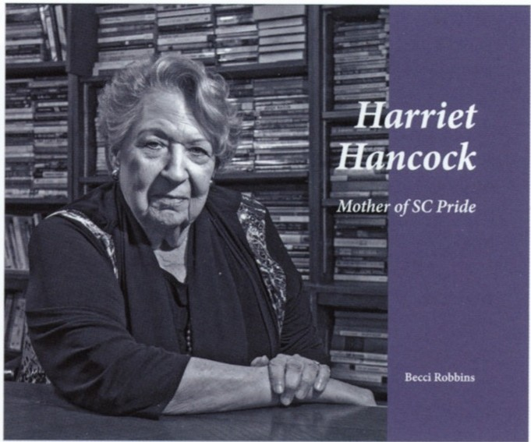When the South Carolina Progressive Network moved to the Modjeska Monteith Simkins House in 2009, they quickly sensed a need for a publication about Simkins' life and work. "We needed a brochure," Robbins says, something "to elevate her history" and to illustrate her connections to the Network and its director, Brett Bursey, with whom she had worked. Located at 2024 Marion Street, the historic home was named to the National Register of Historic Places in 1994 because of its connection to the civil rights movement. It served as a home to the Network from 2009 to 2017, when the Network moved to a nearby address.

"That became my task," says Robbins, who serves as the communications director for the Network, "to fit her enormous life into a brochure." It was, she says, "an impossible task."

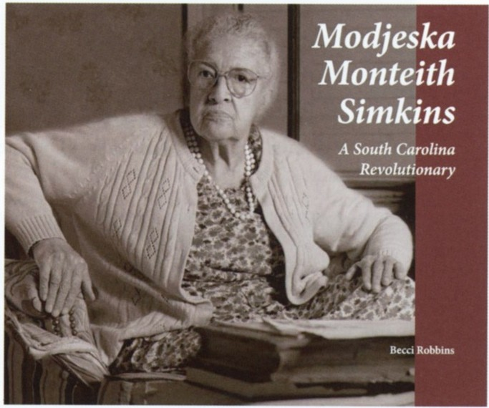Although Robbins didn't set out to write "a trilogy," she soon turned to a companion book about Harriet Hancock and then Sarah Leverette.

The mother of a gay man, Hancock founded the first LGBTQ civil rights organization in the state, a chapter of PFLAG (Parents, Families and Friends of Lesbians and Gays) that was the first in the Southeast. During the AIDS crisis, she helped found Palmetto AIDS Life Support Services (PALSS), and she later helped to organize the first state Pride March, held in Columbia in 1990.

Leverette was one of the first women admitted to the South Carolina Bar, graduated the only female in the USC law school class of 1942, and returned to her alma mater to work in the law library and to teach, the first woman to gain faculty status there. She is, Robbins writes, "a big deal."

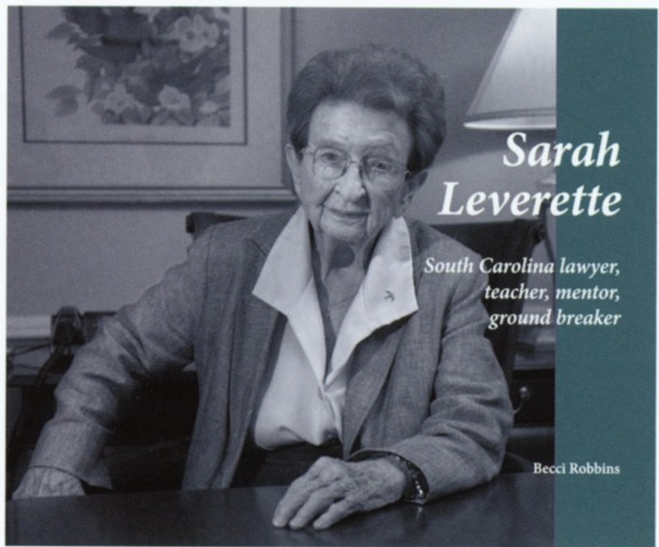Shifting from writing about Simkins to writing about Hancock and Leverette, who were both still alive, was daunting. Because of her respect for the work Hancock had done, Robbins says, "I felt such responsibility to get it right." Although she knew Hancock, she says she only "knew or' Leverette and found the prospect of interviewing her intimidating, at first. "I was really nervous," she says. "I knew h r reputation. I felt like she had this built-in bullshit detector." Like Hancock, though, she was "so welcoming and so warm."

Robbins first got to know Hancock through "dangerous and heartbreaking work" with PALSS, and indeed Robbins now credits Hancock for her career as a progressive journalist. She met Hancock when she

interviewed her about her pro bono work with people with AIDS for a journal published by the South Carolina Bar Association, and when they refused to run it, she went to the progressive journal Point, published by the Grassroots Organizing Workshop or GROW, broadening the piece into a larger indictment of the politics of AIDS in South Carolina and "the horrible way that human beings were treated." She soon joined the work of PALSS as a "buddy" or companion for someone with AIDS. She also became the editor of Point.

Robbins says Hancock was "so generous with her time," the two of them "spending hours at her kitchen table." She smiles, "She would make me lunch because she's a mom and that's what she does." Leverette, on the other hand, had a dining table never used for dining. "It was covered with files, things she was working on." What especially impressed her about Leverette was "how deep and strong her relationships were with everybody in her life," including law school faculty and staff, women lawyers, and the League of Women Voters, with which she was deeply involved.

Leverette was 96 years old when Robbins interviewed her. "After a certain age," Robbins says of women in American culture, "we become invisible." Calling that "another kind of erasure," Robbins highlights the fact that all three women were active well into their 80s

The three books tell the women's sometimes difficult personal stories, but the focus is on their activism. They also put those stories in a broader context, situating their lives and activism in the context of historical events, state politics, and national movements. All three include quotations from the women in highlighted columns titled appropriately, "She Said."

At the end of the Leverette booklet, Robbins says that she hopes that girls and young women pick up these booklets and find themselves moved and impressed by the women's stories. These three women, she writes, "show the power a single citizen can have, given enough passion and commitment."

She adds, all of them deserve full biographies.

Robbins had planned a fourth book in the same format as the first three, this one to focus on South Carolina State Senator Joseph Neal of Hopkins, who passed away in 2017. "His death really crushed me," says Robbins. "He

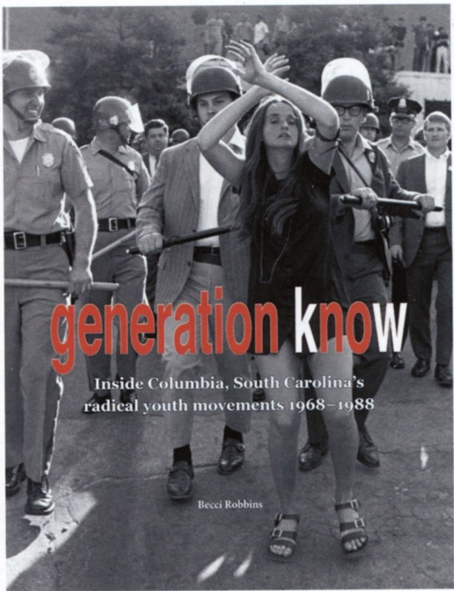

was not just a dear friend," she says,"he was such a force, just this giant light of goodness and decency. We were devastated when we lost him."

Neal had been a cofounder of the etwork and helped to lead it for over a decade, later becoming their "go-to guy" in the legislature for information and support. "I wanted to remember him," Robbins says, but the pandemic and other issues intervened. So, she moved to extend the story about the 1947 SNYC convention, expanding the book to "other things you probably didn't learn in school" about racism, the civil rights movement, and labor history. She also shifted the format to magazine style and size, strengthening the visually friendly and accessible appearance.

When History Denied was released in 2018, Robbins wrote, "I learned so much on this project-not the least of which is how little I know. The more I dug and read, the angrier I got about my miseducation."

IfthedeathofNealled to the pub!icationofHistory Denied, it was Merli Truesdale's death, and Robbins' awareness that his rich experience had never been recorded, that more directly compelled the publication of Generation Know, the fifth book in the series. Robbins says that she had been wanting to write about GROW since she began work there, but Truesdale's death impelled her to start interviewing members of that community.

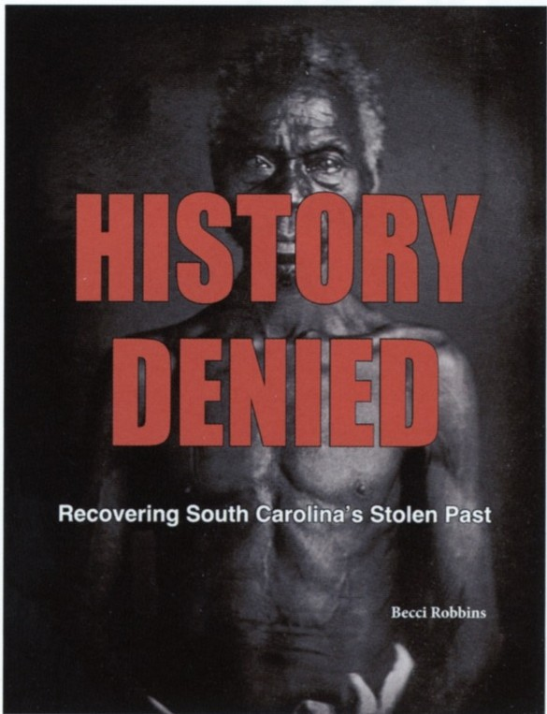Maybe community 1s a fourth and fundamental idea driving her work.

As she worked through Truesdale's archives and interviewed others who had been part of GROW, she began to explore "what led to GROW becoming GROW," expanding the project's focus to take in the Vietnam War and campus unrest at the University of South Carolina. She wrote about antiwar organizing at Fort Jackson and student protests at USC. She wrote about the UFO coffeehouse on Main Street across from City Hall, the antiwar answer to the USO down the street. "Not your mother's USO," Robbins laughs.

All of these books are published under the umbrella of the Modjeska Simkins Schoolof Human Rights, which began offering a series of classes in 2015 to people interested in learning more about Black and indigenous history in the state, civil rights and labor movements, the women's and LGBTQ movements.

"People are hungry for that kind of thing," she says."

As we finish this article, the Associated Press reports that book ban attempts hit a record high in 2022, the highest since the American Library Association began keeping record 20 years ago. While former challenges came from parents about individual books, they are now coordinated by national groups like the ironically-named Moms for Liberty, active in South Carolina, who are demanding sweeping removals and restrictions on books and content matter.

GOP legislators across the nation are trying to keep information about our nation's racial and racist past out of classrooms, and they are removing books about 'LGBTQ people from public and school libraries. Twitter was recently full of images of Florida teachers taping butcher paper over their classroom bookshelves because they don't know if their classroom libraries will pass muster with the state- and self-appointed censors.

Questions about what you can know, when you can know it, and what information you are allowed access to have never felt more fraught.

Urgency, history, accessibility, community. In times like these, this work matters. These books matter.

**Booklets on SC history by**

# Becci Robbins:

Modjcska Monteith Simkins: *A* South Carolina Revolutionary (2014)

Ilarrict I lancock: Mother of SC Pride (2016)

Sarah Leverette: South Carolina lawyer. teacher.

mentor. ground breaker (2016)

11istory Denied: Recovering South Carolina's Stolen

Past (2018)

Generation Know: Inside Columbia. South Carolina's radical youth movements I%8-1988 (2022)